**CSS (Cascading Style Sheets)** is a code language that allows you to control the appearance of your web page. It is used on almost every website.

Web pages are composed of **elements** like headings, paragraphs, images, articles, and more. These elements are created in **HTML**, and their appearances are customized in **CSS**.

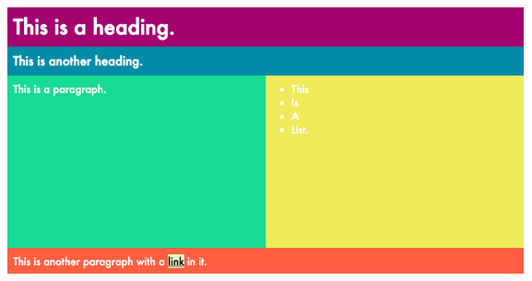

**Elements as boxes**

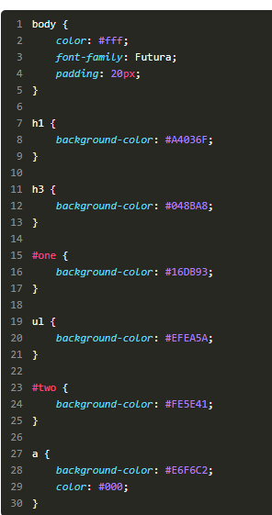Creating layouts requires complete understanding of one key concept: **every HTML element lives in its own box.**This concept is called the **box model.**

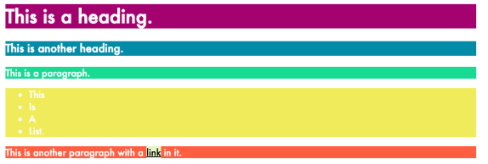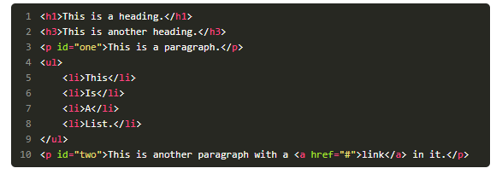

* "Boxes" for block elements take up the whole page, while "boxes" for inline elements will only be as big as the element itself.
* Containing elements or "containers" (ex. a div) have other elements inside them.

## **Add custom borders to elements**

In CSS, you can control a border's:

* **width** (thin, wide, 5px, etc.)
* **style** (solid, dashed, etc.)
* **color** (hex code, RGB value, etc.)

### Border syntax

Before we look at border value examples, there are two general ways to **set borders**:

* **a longhand way** where you list out each value in a different property (ex.  border-width  ,  border-style  , and  border-color  ).
* **a shorthand way** where you combine all values into one property called border

You can set borders in CSS using one simple property called border.

You'll often set borders the shorthand way because it's faster and more concise.

***In it, you will specify three border properties in the following order:***

* width
* 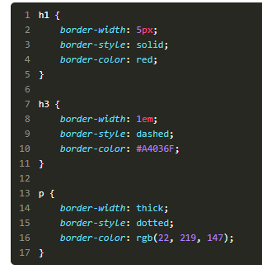style
* 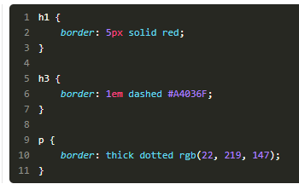color

**shorthand method**

**the longhand way**

### Setting border width

**Border widths** can be set as either **pixel values**, **em/rem values**, or using **a word** that CSS has already pre-defined, like "thin," "medium," or "thick."( 1em means the border will be 16px wide)

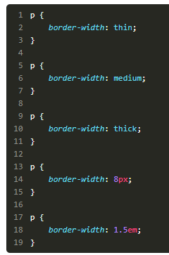

### Setting border style

In reality, you'll most often specify a "solid" **border style**.

Here is the full list of possible options for setting borders in CSS:

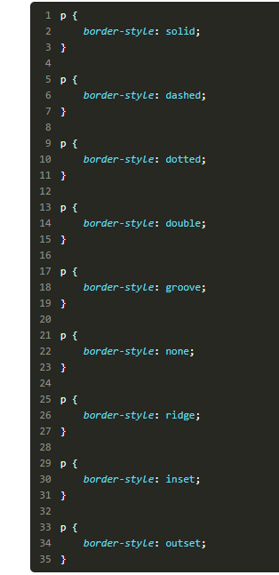Solid, dashed, dotted, double, groove, hidden, none, ridge, inset, outset

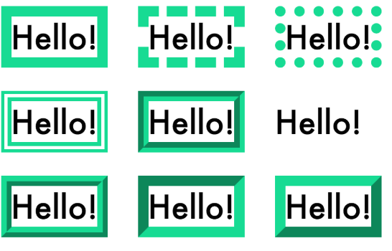

You can even set specific border styles per side by using property names that specify the top, bottom, left, or right border:

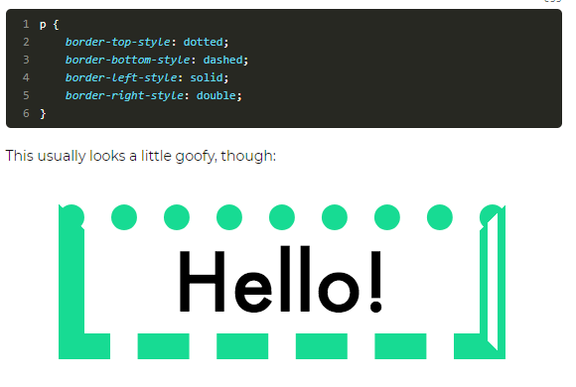

### Setting border color

Set **border colors** the same way you set most colors in CSS, using:

* **hex codes**
* **RGB or RGBA values**
* **color names**
* **hsl values**

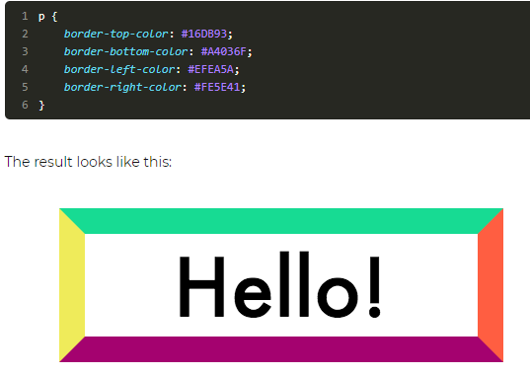

### Setting border radius

Lastly, you can also set rounded borders by using a property called  border-radius  using em/rem values, pixels, or percentages:

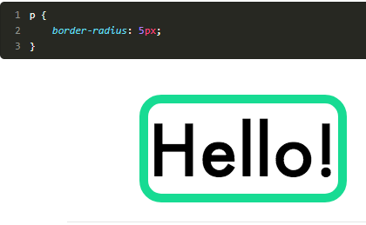

### Recap

* Each HTML element has a border.
* To set the width of a border, use  border-width  and define the size with pixels, em/rem, or special CSS words (thin, medium, thick).
* To set the style, use  border-style  and choose a style from the list of available CSS words.
* To set the color, use  border-color  and use either hex, RGB, or RGBA color codes.
* To set width, style, and color all at once, use the  border  property.
* To set individual borders, use top, right, left, and bottom (ex.  border-top-style ).
* To curve the corners of a border, use  border-radius  .